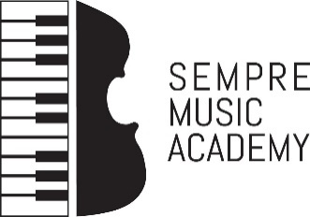

COVID-19 procedure

Dear Parents,
In preparation for our return to lessons, week beginning Monday 7th September, we ask that you read and sign the following declaration.

To help prevent the spread of COVID-19 we ask every parent to complete and sign this form before your child’s first lesson.

Student Name: ………………………………………………….

Please answer Yes / No to each question

1. Do you have symptoms of cough, fever, high temperature, sore throat, runny nose, breathlessness or flu like symptoms now or in the past 14 days?

2. Have you been diagnosed with confirmed or suspected COVID-19 infection in the last 14 days?

3. Are you a close contact of a person who is a confirmed or suspected case of COVID-19 in the past 14 days (i.e. less than 2 metres for more than 15 minutes accumulative in 1 day)?

4. Have you been advised by a doctor to self-isolate at this time?

5. Please provide details below of any other circumstances relating to COVID-19, not included in the above, which may need to be considered to allow your safe return to lessons.

If your situation changes after you complete and submit this form, please inform your teacher immediately.

Name: ……………………………………………. Signature: ……………….… Date: …………….

- Please arrive 5 mins. before your lesson time.
- Please wear face mask.
- Teacher will meet you at the front door.
- Temperature will be checked by teacher at door.
- Beginners/younger students may be accompanied to their lesson by one parent only.
- Siblings receiving back to back lessons may arrive together and stay in the teaching room for the duration of their collective lesson.
- There will be hand sanitiser in every teaching room and all other equipment will be sanitised between lessons.
- Please be at front door 5 mins. before the end of your child’s lesson for prompt pick up. It will not be possible for students to wait inside the building for collection.

